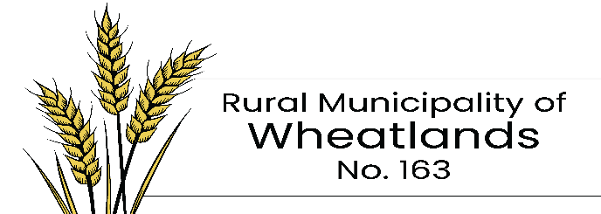

**OVERWEIGHT PERMIT APPLICATION**

TO WHOM THIS MAY CONCERN:

In accordance with the provisions of section 36(1) of “The Highways and Transportation Act 1997”, and sections 18 or 21 of “The Municipalities Act” permission is hereby

DATE__________________ PERMIT No.__________________

|  |  |  |  |  |  |  |  |  |  |  |  |
| --- | --- | --- | --- | --- | --- | --- | --- | --- | --- | --- | --- |
| GRANTED TO | | | | | | | | ADDRESS | | | |
| To Transport (Goods) | | | | | | | |
|  | | | | | | | |
| License | | Gross Vehicle Weight | | | | No. Axles | | Steering Axle Weight | | | Spacing |
| 2nd Axle Group | Spacing | | | 3rd Axle Group | Spacing | | 4th Axle Group | | Spacing | 5th Axle Group | |
| FROM | | | | | TO | | | | | | |
| VIA PUBLIC HIGHWAYS | | | | | | | | | | | |
|  | | | | | | | | | | | |
|  | | | | | | | | | | | |
| FEE FOR THIS PERMIT | | |

Valid from ________________A.M./P.M._____________________ ________ to ____________________ ______

**This permit is also subject to the following terms and conditions as well as those listed on the reverse side of this form.**

**_____________________________________________________________________________________________**

**_____________________________________________________________________________________________**

**_____________________________________________________________________________________________**

Rural Municipality of

__________________________________________ Per ________________________________________

Location

[Maximum charge as determined by the Minister of Highways and Infrastructure is $25.00 per single trip permit / $100.00 per multi-trip permit]

Conditions of Permit

1. This permit shall not be valid on any road, public or private, other than the public highways stated herein.
2. The issuance of this permit does not allow the permittee to exceed 10 kg per mm width of tire (manufacturers stamped dimension) on any wheel or group of wheels unless the tire size and axle loadings are specified in the permit.
3. The issuing of this permit shall not relieve the holder thereof from responsibility for any damage caused said highway, or to any public improvement, or to any person or property, by reason of the operations covered by this permit. The holder of this permit agrees that he will so carry out his operations as to cause a minimum of interference with the traffic on the said highway and must also indemnify the Rural Municipality and Ministry of Highways and Infrastructure against any claims in connection with traffic accidents which occur as a result of said operations.
4. The issuing of this permit does not relieve the holder thereof from the requirements of any legislation whether federal, provincial or municipal.
5. No movement of overweight vehicles will be permitted during adverse road and weather conditions. During such conditions an enforcement officer may temporarily void the permit until such time as it is in his opinion, safe to proceed.
6. The permittee shall before crossing any bridges or culverts, which are inadequate to carry the vehicle and its load, reinforce them to the extent necessary.
7. The permittee shall pay and hereby undertakes to pay to the municipality on demand such sum as may be required to remedy any damage caused to the said roads, bridges or culverts through the operation of the said vehicle or vehicles or in any way arising from the said operations covered by this permit.
8. It is the responsibility of the permittee to ensure that the vehicle has adequate insurance coverage and is properly licensed to transport the load specified on the permit. (This permit does not allow for weight in excess of the **registered gross vehicle weight** of the vehicle. For information call toll free 1-800-667-7575.